**Microprocessor Systems and Interfacing**

***CEP Proposal***

***CALCULATOR using PIC18F452***

**INTRODUCTION:**

This project focused on design and implementation of a microcontroller based calculator which will perform simple arithmetic using a switches and a 16x2 Liquid Crystal Display (LCD). It takes 15-bit data through switches which are connected at PORT B and other two switches are connected on port C and their different configuration will do different arithmetic operation (e.g. 00 for addition, 01 for subtraction). This allows the program for the arithmetic operations to be simple. The results obtained are displayed on the LCD display.

**Theory of Design**

The circuit for a calculator which will perform simple arithmetic operations in the PIC 18F452 Microcontroller, using a calculator keypad and 16X2 LCD display, is shown inFigure1. The keypad has 16 keys: 10 numeric buttons, 4arithmetic operations, equals and clear. The results obtained are displayed on the LCD display

**Desired Output will perform**

The calculation and result are displayed. For the divide operation, the result is displayed as result and remainder. The clear key erases the current display, and a new calculation can be entered. If an invalid key sequence is entered, the program should be restarted.

**PIC Microcontroller architecture** is based on Harvard architecture and supports RISC architecture (Reduced Instruction Set Computer). PIC microcontroller architecture consists of memory organization (ram, rom, and stack), CPU, timers, counter, ADC, DAC, serial communication, CCP module and I/O ports. PIC microcontroller also supports the protocols like CAN, SPI, UART for interfacing with other peripherals.

We are using **PIC Assembly and C language programming** to code the calculator using PIC 18F452 using Proteus and MPLAB.

**PIC Input/output ports** will be used for data input and output. Input on which the operation has to be performed will be allotted through input ports and after the calculation the output will be displayed through output ports.

For data transmission **Serial Communication** will be used. UART (Universal Asynchronous Receiver Transmitter) is a serial communication interface which is used for transmitting and receiving data. The UART feature is first initialized and then it can be used for transferring data.

PIC Microcontroller consists of both Hardware and Software **Interrupts**. If the interrupts are generated by external hardware at certain pins of microcontroller, or by inbuilt devices like timer, they are called Hardware Interrupts. While Software interrupts are generated by a piece of code in the program. Here software interrupts could accur.

**SCHEMATIC DIAGRAM:**

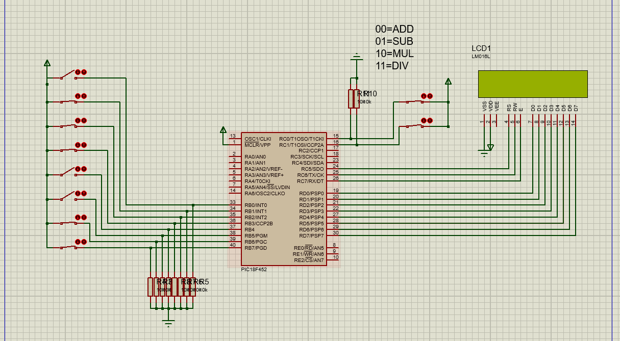

**Flowchart:**

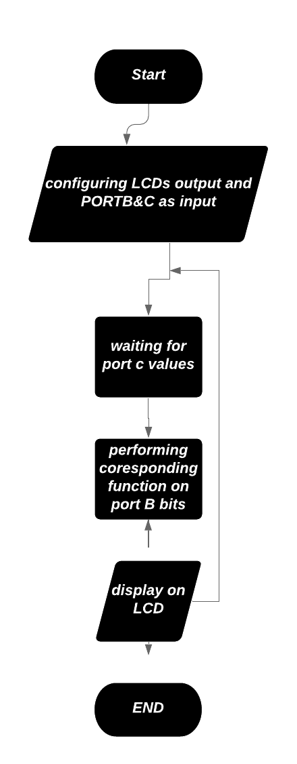

**Overview:**

In this project we will create a Calculator by using **PIC18F452**, in total **10** switches will be used where 4 switches will be used for higher bits and 4 will be used for lower bit value other 2 switches will be connected at PORT C are used for deciding the arithmetic operation.

_____________________________________________________________________________________